

RAPID Build
API Datagrid
User Guide

Prepared by: Rapid Solutions and Consulting LLC
Last Updated: September 25, 2015

Copyright © 2015, Rapid . All Rights reserved.

Table of Contents

Introduction 3
1. Installing Rapid Build 4
2. Validate Envirnment of Rapid Build 5
2. 1 Environment setup and validation screen 5
2. 2 BWP Selection Screen 10
3. Using Rapid Build and functionality 12
4. Using Swfit Build Grid Program 19
5. Column in use 23

Introduction

This document is use to guide you how to use the Rapid Build using the API DataGrid .If you wish to know the use and the need of setting or software prior for Rapid Build please read the Rapid Build - User Guide.pdf
The document would guide you how to use and how to react with the error during using it.The Rapid Build API DataGrid act very similar to the Oracle forms limitation and error ,thus,most of the error is the data that try to input to the Oracle.The error and the suggestion would to be similar to the Oracle form error and suggestion.

1. Installing on Rapid Build

- Download the Installer file from RSC download Web site.
- Run the installer file (example: RapidBuild-1.3.X.exe) or the unpacked version (ZIP file)

Figure 1.1: Rapid Build Selecting Path

Note:You can reselect the location where to install the software. By default is the path you see in the above figure. Then click OK button to start installing.

Figure 1.2: Rapid Build Installing

After completing the Installation, a RapidBuild shortcut Icon will appear on your Desktop:

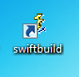

Figure 1.3: Rapid Build Icon Short Cut

2. Validate Environment of Rapid Build

This section explains how to use the RapidBuild to create a new Oracle Application Instance step by step. Before running injectors, you must have both BWP and BWE file which placed in the same folder.

- RapidBuild Launch

- Launch Rapid Build by double clicking on
- its icon located on your Desktop.

  - 2.1 Environment setup and validation screen

This screen will ask you to setup a RapidBuild Environment and save it as a file (.RapidBuild is the file’s extension) from either local drive or network drive where you place it on. That file contains all information related to the connection to the target server (IP address, port number, FTP setups, etc.) that is necessary prior to running the injectors.
RapidBuild will not allow you to go further until the information has been validated.

Note that the unpacked distribution contains sample Environment files for Oracle release R11 and R12, you can use those as a template:
environmentTemplate_R11.RapidBuild
environmentTemplate_R12.RapidBuild

If you have been supplied with an Environment / BWP pair of files by your implementation partner, you should be sure to select the correct files and not use the default.

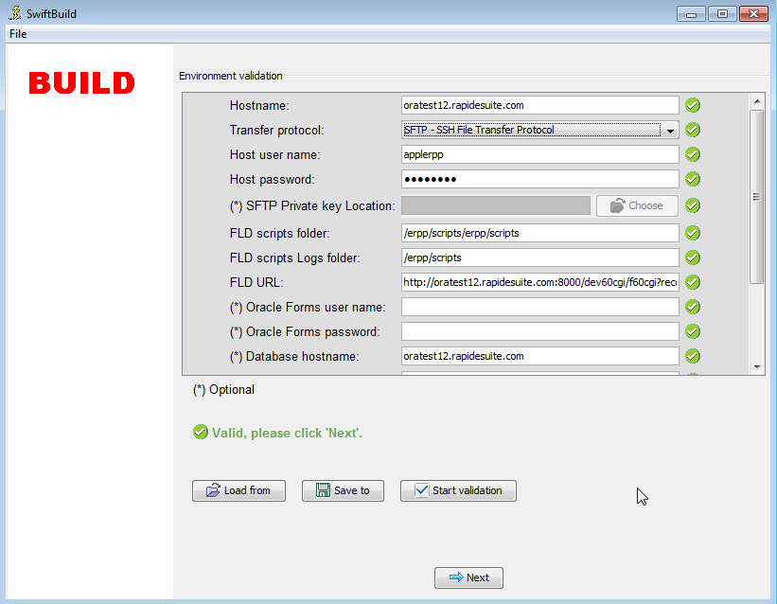

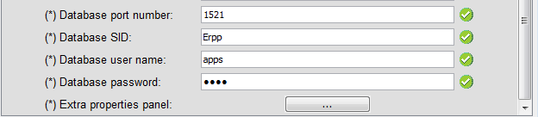
Figure 2.1: Environment setup

Load from buttons are at your available if you wish to load the existing file.While the information is validating you can stop validate by clicking at Stop Validation button ,you can make a changes to the inforamtion directly in each text box,Save to button use to save the changed file or existing file to the browse location .After make a changes to the file you must click at Start validation button to validate the information .

Environment parameters:

Here is a completed reference of each parameter and what needs to be keyed in:
Please replace the highlighted values in RED with you server configuration. Consult your System Administrator for any parameters you are unfamiliar with.

- Host Name = oratest12.rapidesuite.com
It contains the host name to access Oracle forms server.
- Transfer protocol = SFTP or FTP or SSH
It contains the protocol chosen necessary for a FTP or SSH connection to be established in order to transfer scripts or launch ADADMIN, ADPATCH. The possible values are: SSH for a secure connection or FTP for an unsecured one. SFTP is SSH but authentication is done via a private key file.
- Host user name = applerpp
It contains the login necessary for a connection to be established in order to transfer scripts or launch ADADMIN, ADPATCH.
- Host password = Applerpp
It contains the password necessary for a connection to be established in order to transfer scripts or launch ADADMIN, ADPATCH.
- Private key location = D:\swiftsuite-dev\trunk-dev-sb\deploy\privatekey.txt
It contains the private key necessary for a SFTP connection to be established in order to transfer scripts.
- FLD script folder = erpp/scripts/erpp/scripts
It contains the location where the injectors will be transferred to on Oracle Applications’s host. Note that Oracle EBS stores the location in the environment variable: FORMS60_TRACE_PATH.

This variable can be edited in the file: /erpp/erppappl/ERPP_hostname.env on Oracle EBS 11.5.10.2. Make sure that the values in this environment variable and “FLD script folder” and “FLD URL” are the same; otherwise the injection will stop at the login page (Oracle not able to find the script).
- FLD script Log folder = erpp/scripts
It contains the location where the injectors FLD logs are stored on Oracle Applications’s host.
- FLD URL=http://oratest12.rapidesuite.com:8000/dev60cgi/f60cgi?record=%s.log%20play=%s
It contains the full URL required to launch Oracle Applications playback files. You will need to update it and change the host/port and folder parameter.
- FLD Form user name = ?
It contains the Oracle user name necessary to connect to Oracle Application forms.
It can be any valid Oracle user name who can login the the Oracle portal page.
- FLD Form password= ?
It contains the password for the above Oracle user.
- Database host name = trcmal11510p1.dbaora1.com (optional – use with the migrate Rapid Build)
It contains the host name to access Database server.

- Database port number = 1521 (optional – use with the migrate Rapid Build)
It contains the database port number to access Database server.
- Database SID = erpp (optional – use with the migrate Rapid Build)
It contains the database SID to access Database server.
- Database User name = apps (optional – use with the migrate Rapid Build)
It contains the Database user name necessary to connect to Database server.

- Database password = apps (optional – use with the migrate Rapid Build)
It contains the password for the above Database user name.
- Extra properties
Extra properties (example: replacement tokens) can be entered via that window.

Note that you can save any configuration changes to a file that you have made by clicking to ‘Save’
Click Next button when you are finished validating the configuration changes.

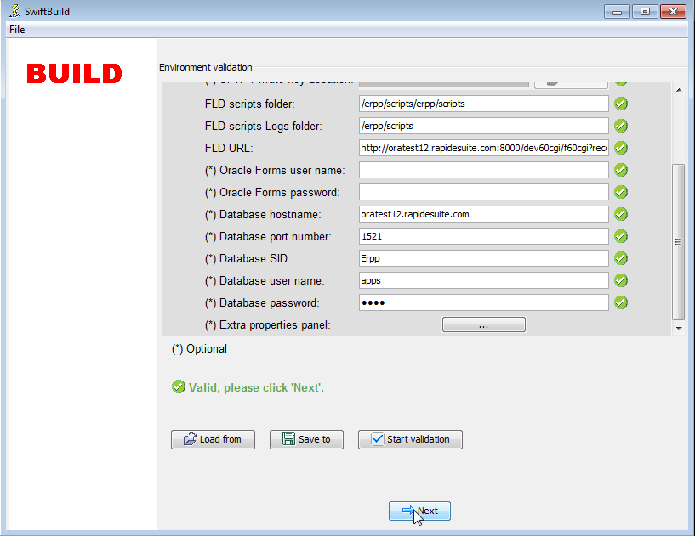

Figure 2.2: Environment

  - 2.2 BWP Selection Screen

This screen will ask you to select a RapidBuild Package file (.BWP is the file’s extension) from either local drive or network drive where you place it on. A BWP file contains all the injectors to be applied to an Oracle Application Instance. Examples of injectors are Playback files (FLD used to build an instance), HTML pages to display manual steps to be done, Linux scripts, adadmin, adpatch activities, etc. The RapidBuild will not allow you to go further if the selected file is not a BWP file or if the format is not recognized (e.g., corrupted file, etc.).

As you can see Figure 2.4: BWP Selection to browse to sepecific path to select the file after the content of the selected package will be displayed for your information. Click Next button if nothing special is required after selecting the file.

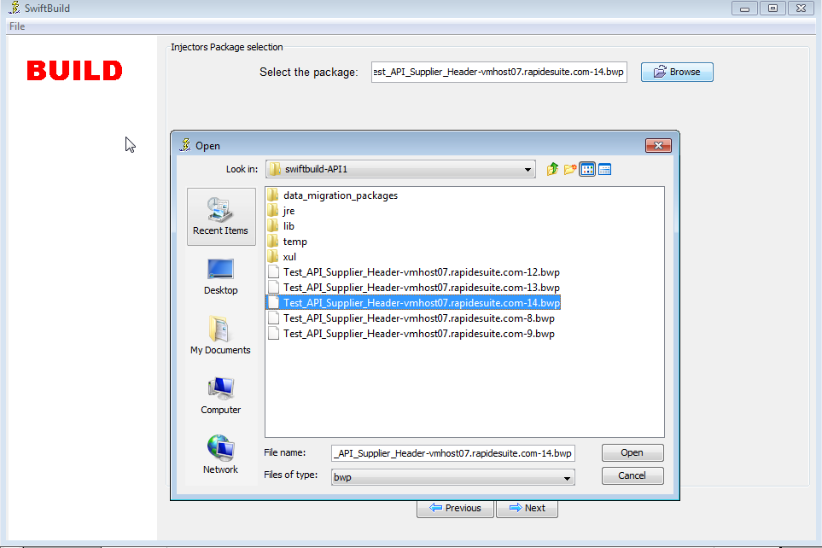
Figure 2.4: BWP Selection

If the RapidBuild validate the BWP and the currently running BWP is a API DataGrid which use Grid data to inject ,The RapidBuild will have to validate the package whether is it the valid one.Thus,here there might be a case that the database have no package at all ,or invalid version.The RapidBuild will ask to install the package before going further – by clicking at Install button
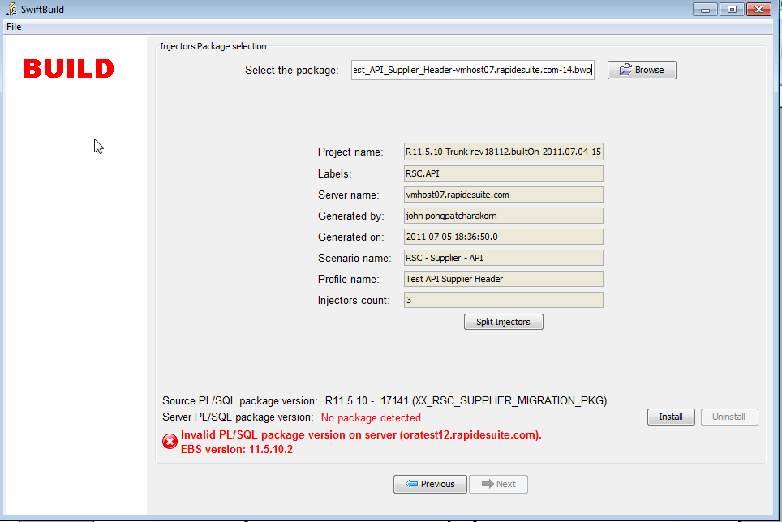
Figure 2.5: Invalid Package need to install

If the version of the package is already valid or you have installed the package then you can go further by clicking at Next button.
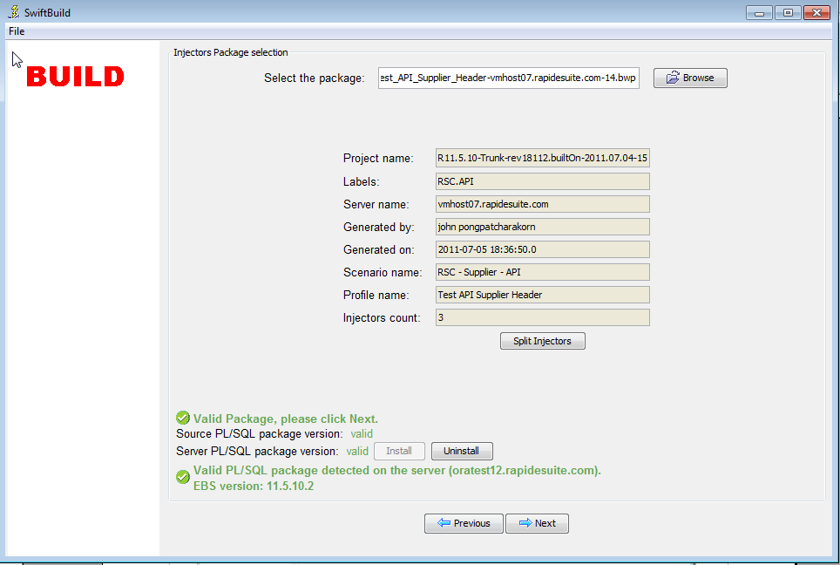
Figure 2.6: Pakage Valid

3. Using Rapid Build and functionality
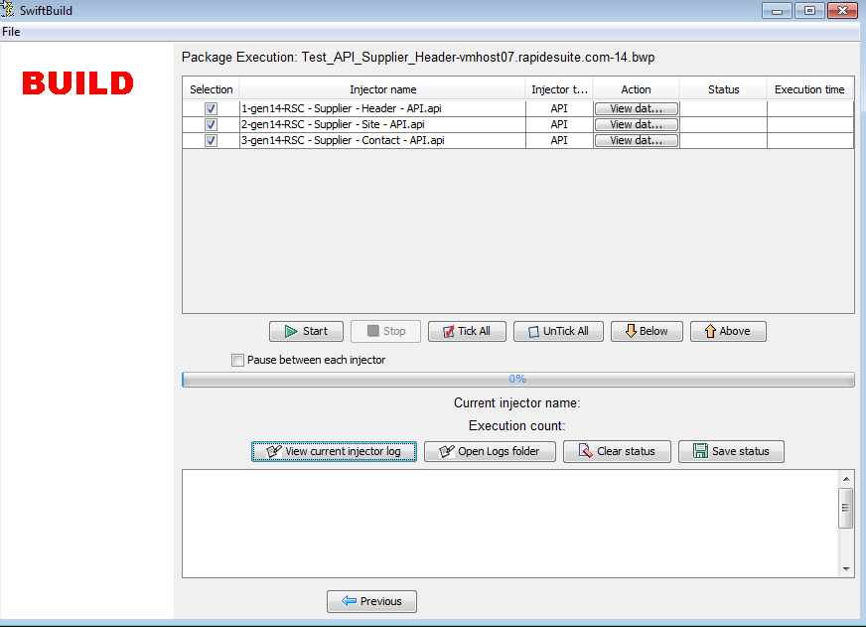
Figure 3.1: Rapid Build

For example with the Supplier ,we have three inventories implementing the API DataGrid Rapid Build ,namely,
- RSC - Supplier – Header - API
- RSC - Supplier – Site – API
- RSC - Supplier – Contact – API

To view the data that we are about to implement ,click at View data button in the Action Tab for which Injector Name you wish to see them then the Grid data will pop up .
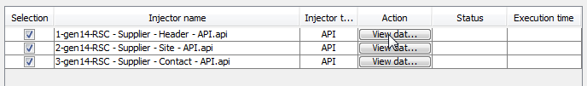
Figure 3.2: View Data

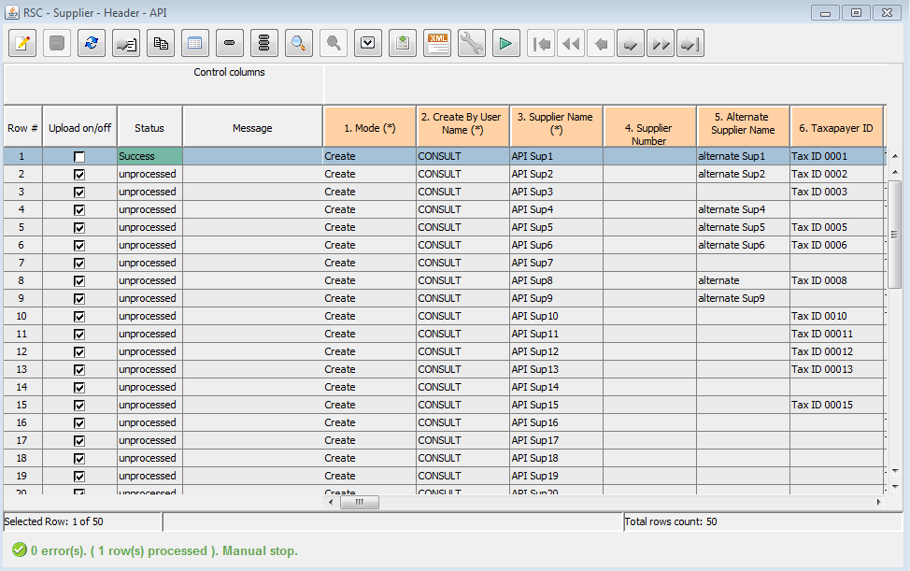
Figure 3.3: DataGrid Panel

The use of the DataGrid Control Pannel :


This is a Edit button , when you desire to make changes in the data in the Grid. When you first select the edit it will prompt you to select the Operating Units , please select Operating Units that you are currently using to inject relate to the responsibility.
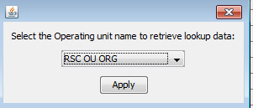
Figure 3.4: Selecting Operating Units


When you are in the Edit mode , when you have done the changes to the data and now you wish to save them.

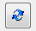
When you are in Edit mode , and you wish to cancel what you have changed .

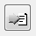
This button is use to Create a new record with all fields are empty to the first top record, here you can not save if the required fields are not entered.

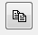
This Copy button will copy the entire row of the high lighting (Blue high light color) row only.It will copy one row at a time.


This button is a Mass update ,once you click it will pop up the panel to select the column and input the data .

Note: Once you apply this function will it apply the changes to all the rows for all the columns you have enabled. (To enabled you have to select the check box in front of the column name too)

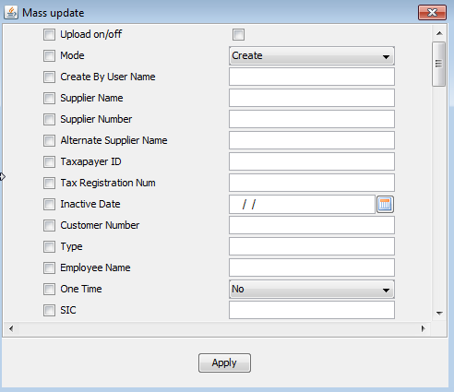
Figure 3.5: Mass Update Panel


Delete button will delete the high lighting row , once you clicked at this button the pop up will ask to confirm the action again .If you wish to delete click at Yes else click at No .
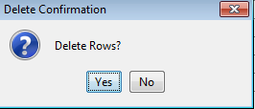

Figure 3.6: Delete Confirmation

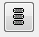
Mass delete button , this will delete all the rows which are filtered by the function filtering and sort .

Note: when the filtering function is not filtered if you using this it would mean to delete all the rows. Once you clicked at this button the pop up will ask to confirm the action again .If you wish to delete click at Yes else click at No .
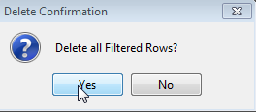

Figure 3.7: Delete Confirmation


Filtering and sort button ,this is use to filter the data to focus only those rows we filtered.The result may be show some rows but it does not mean that the rest was deleted but it just hidden from the Grid data.
When you click at it there will be an pop up panel for you to select column to filter.
For example here I have filtered column Supplier Name that it should contain 1 .Once you done with you filtering function and you wish to use it ,click at the button on the top right of the panel(at the mouse pointer focus) .
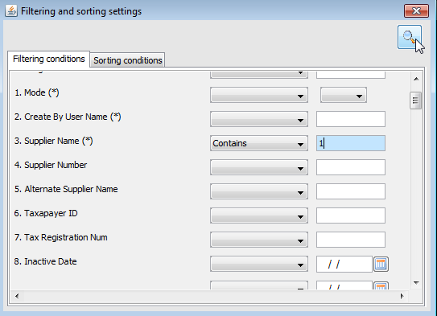

Figure 3.8: Filtering rows

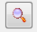
Reset Filter button use to reset what we have filtered in the function, the result of this would display all the rows.

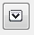
Reset Value to blank (Update mode only) , If you wish to update the column to Blank value (empty) in the Oracle form ,you have to use this feature to set it.If you design to update some field to blank it does not mean that you pass empty value to the API DataGrid program ,this will not do any thing update to the field.Thus if you design to do so you must use this feature.
Once you click at the button there will be an pop up panel which you have to select the column which you need to update to blank value.

Note: This will update every columns what ever you have selected apply to all the rows which selected in the Upload on/off column.Please check only the row you wish to update data to blank.
The one which implementing this reset value feature those column will be in yellow shade.(it might be green when your cursor at it)
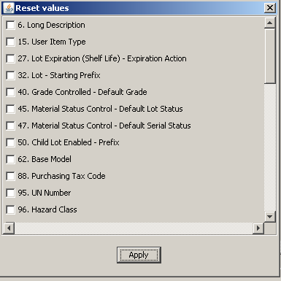

Figure 3.9: Reset value to Blank

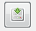
Import button to import data file from the location you have browse .The file must be in XML format and their should have the same number of columns and data type.Once you import the data to the Grid the main panel will refresh to contain the imported data.

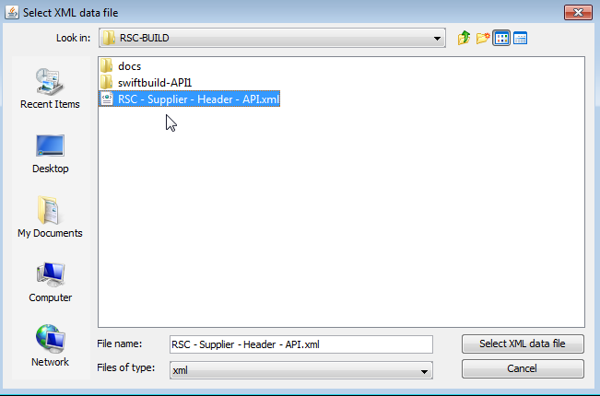
Figure 3.10: Browsing file to import


Export XML button let you to export the data in the Grid to the XML file format.It would be helpful when you have fixed something in the data in the Grid and you wish to keep the copy for future use or to import these data back to the Swift Config.
Once you click at button there will be an pop up panel requiring location path where you wish to save this file output.The file name would be default to the same as the inventory name .
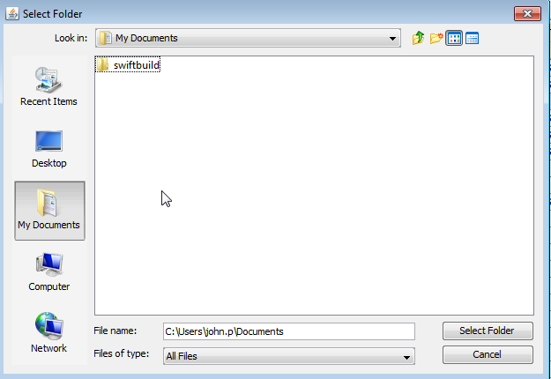

Figure 3.11: Browsing file to export


Export Excel button this button export the data in the DataGrid in the format of Excel file ,after you click at this button the file will be pop up to you.The name of the file will be prefix with the RapidBuild then allow with the auto generated number.It is better for you to save the file with your own name and the location path where you want it to be saved.


Option button contain two function ,that is, one for hide all empty columns for every rows.That mean it would hide the column only if all the rows for that column is empty.
Second one is to show only those fields which are required(mandatory) field .
Here an sample when we selected to show only required columns.

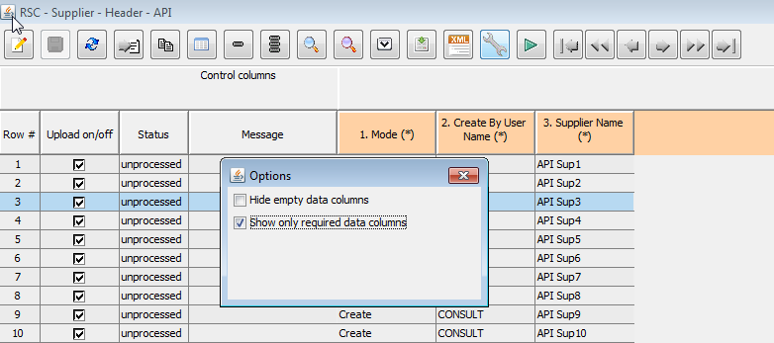

Figure 3.12: Using option to select only required field


Upload data button this one is similar to the start button in the main injection to panel ,but when you click at this button it will upload the data only for this Grid Panel.But the start button outside in the main panel will upload all what ever number of inventories we have.Once you click start it will start upload the data and you can see the status message ,You can even click at Stop Button when you desire to stop the process.


The above is the cursor control ,when you desire to move the cursor to particular record like next record ,previous,go to last record/first record,etc
You can even control the cursor by using the mouse by clicking at the particular record or move the slip bar to top or below record.

4.Using Rapid Build Grid Program

Once you upload the BWP ,then it will let you to the injection panel.All the functionality is similar the the previous version which you can refer Rapid Build - User Guide.pdf document.

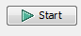
When every thing is ready let start how to injecting:

This is simple and similar to the previous tool ,by clicking at Start button
The Rapid Build will start its process one by one in the order top to bottom that appear to you .

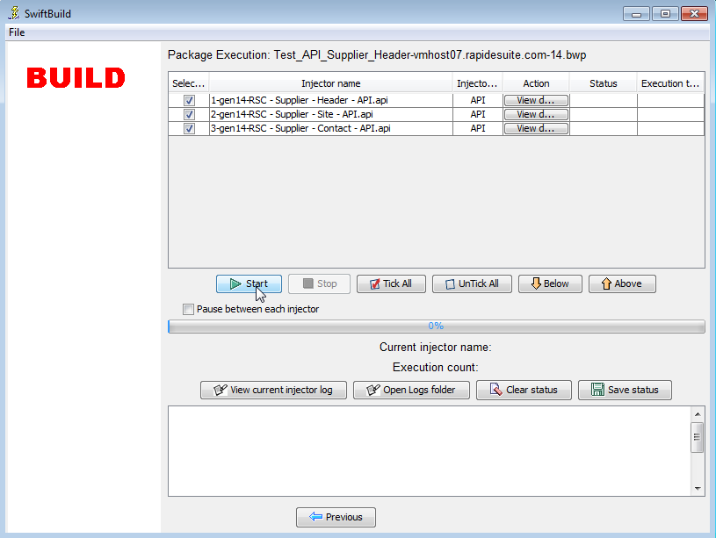
Figure 4.1: Using option to select only requried field

In order for the RapidBuild DataGrid to upload the data for the second inventory in the select list , the first one must be fully execute uploaded all the rows without any error.
For an example here if the first one got success upload all the records it will move to upload the second one,as you can see the second one get an error ,thus, it will stop at this process and pop up the current DataGrid Panel that having an error .Figure 4.2: one Success ,one fail show the sample of one inventory got success and the one got error ,thus it stop here at second process. Figure 4.3: Pop up error DataGrid Panel ,after it get an error it would pop up an DataGrid panel an show all the rows status and error message .

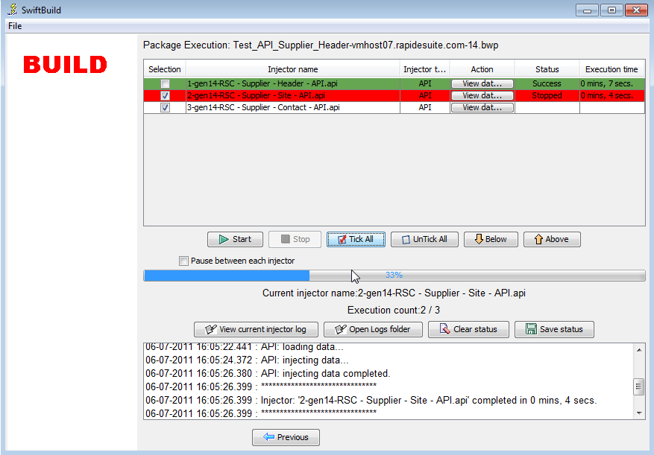

Figure 4.2: one Success ,one fail

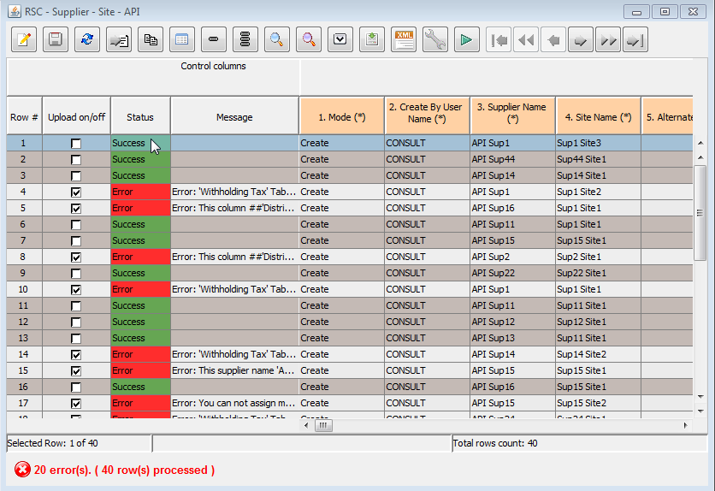
Figure 4.3: Pop up error DataGrid Panel

For each of the error there is an error message with it ,which if you bring your cursor to that particular error record, it would show the error message in the below of the pannel with the error message detail.

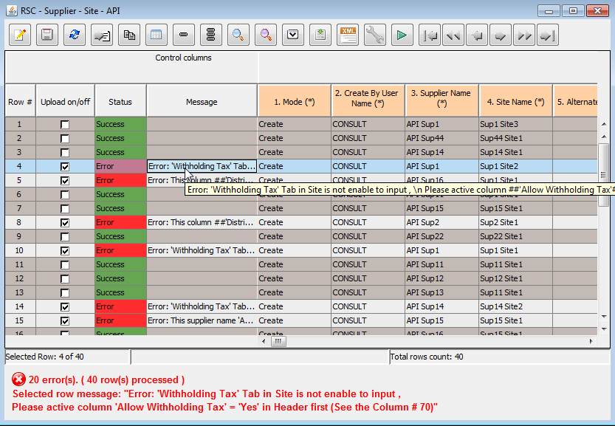
Figure 4.3: Show error message

For each an error message there will be an column number where cause the error , this would help you to find which column number ,as in the above sample error say to see the column #70 .Thus to see the column we can use the scroll bar to move to the record. Each of the column already have got the number indicated ,thus, it would be easy to find it out.
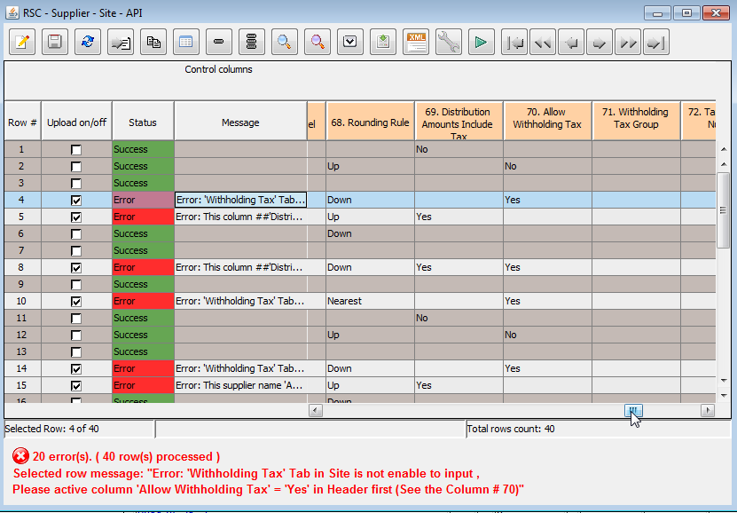
Figure 4.3: Move to error column

For all the error that occur ,the message of the error would give an appropriate message why it cause an error.Thus you can fix the data by clicking at Edit Button then edit each error out.
For those records that already got success ,that mean it already succeeded upload to the database which you can check in the form.

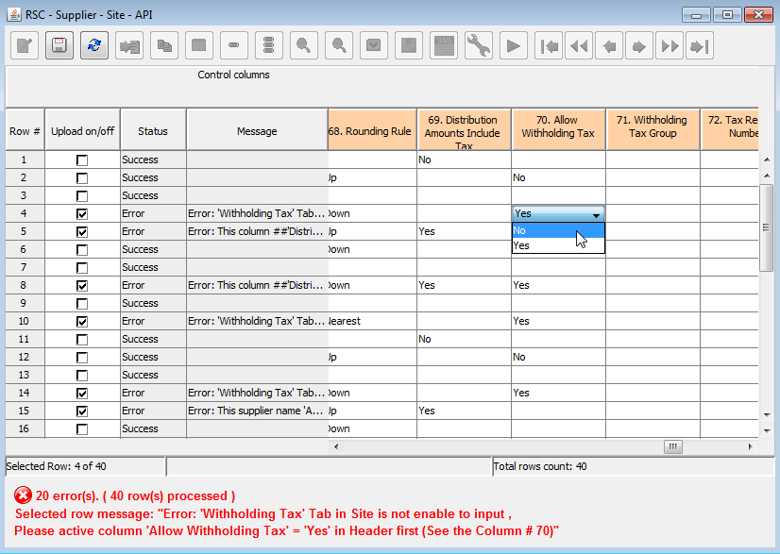
Figure 4.3: Fixing the error

Once you complete fixing the error records you can start upload again.Here if the status is already success the Rapid Build will not take those succeeded record to upload again.

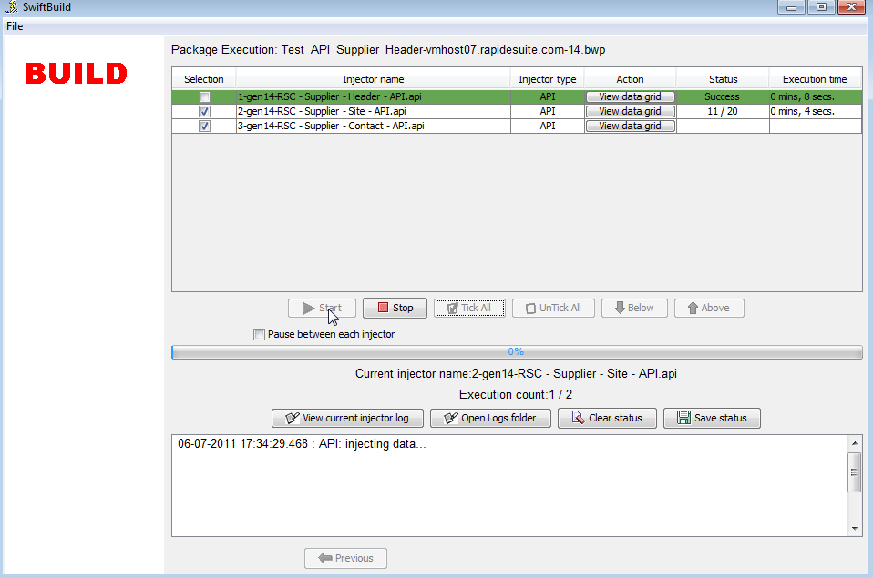
Figure 4.4: Click start to upload again

Note : If you fixed something in the DataGrid it do not over write the main data in BWP ,thus, if you desire to keep what you have fixed ,please use export function .
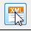

For the next time you start Rapid Build by using the same BWP that contain same set of data if they contain the success upload record which already uploaded once before.When you trying to upload it again ,this time it would give an error message stating that the record already existing. That mean you can not upload it again.Otherwise it would have a duplicate data in your oracle form server.
Note : If you wish you keep only error record you can use the function filtering to filter only the success record then use mass delete to delete all the success . Now you will get only those that did not upload and error if further more you wish you keep copy the data ,you can do it by using the export function.(to import to config suggests to use different Label)

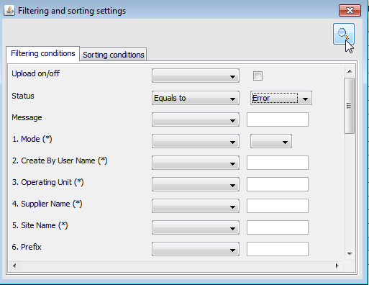
If you wish to see only the error record in order to rectify them also use the filtering function but filter only those status equal to error.

Figure 4.5: Using filter to see only error records

5.Column in use

Each of the column name would contain three things
1. Column number which will indicate the column number which help you to easier to differentiate them .
2. Column Name ,this is the name of the column which most of them are the same name as in the display fields in the Oracle Form Server .
3. Requirement fields, some of the column is mandatory to input the data which indicate by "(*)" ,in order to save then DataGrid ,these column must be fill in..
Common Column :
This would explain the column that would be appear in most of the DataGrid columns , which might not be a part of the data in the form but this value are required and make the program running smoothly and help us to understand unclear doubt .There are few columns which would be listed below:
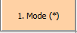
Mode Column :
This indicate the mode which you wish to operate ,there are two mainly two mode ; Create and Update.
For some scenario we might have only create mode only such as Supplier R11.

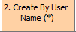
Create by User Name :
For every transaction in the Oracle which we are going to input in the form need to have the user name create it.Thus this column is the user name that are available in the Oracle Form Server.
Each of the record will be created by this user name column.

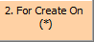
For Create On :
At for some instance , one function can be implement and reusable the ability to create or update in similar topic but might appear in different form or under different aspect view.
Thus For Create On is column will be help us out that what aspect we want it to be create/update . For example Customer communication (Telephone) , this communication can be create in the Customer Header , site , contact (both account contact and site contact) .This column would help us out where exactly we want to create this communication to by selecting the value in the column.
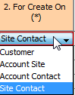
Figure 5.1: Selecting different aspect to operate

